**Year 9 Revision**

Biomes and Food Security

* Revise SPICESS
* Outline what a biome is and provide an example
* Revise food security (definition)
* List ways we can improve food security
* List 3 causes of food shortages
* Outline some advancements in Commercial Agriculture that have led to improvements in food production
* Describe what a developed country is and provide examples
* Describe what a developing country is and provide an example

*There’s growing investment in agriculture around the world to feed an expected population of 9 billion by 2050. But as emerging economies grow in Africa and Asia, consumers in those regions are switching to a more western diet. It’s a diet many blame for obesity, as well as diabetes and cardiovascular disease. However, many others say that people have a choice as to what to eat. They don’t have to buy foods rich in fat and sugar.*

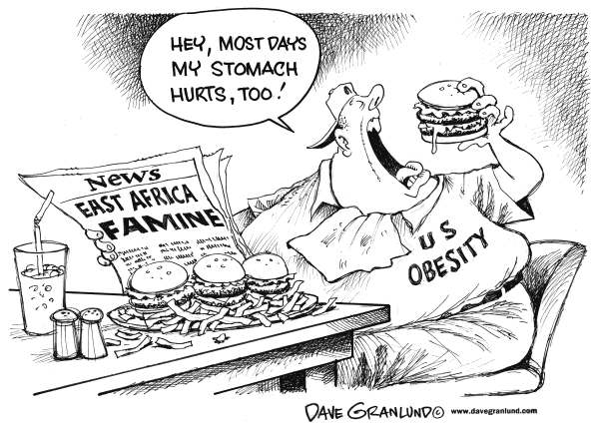Referring to the source below, outline the message of the cartoon. For example, what is it saying about food security and the problems with world is facing?